# Current Advert Campaigns

## analysis

### WWF (forest fires):

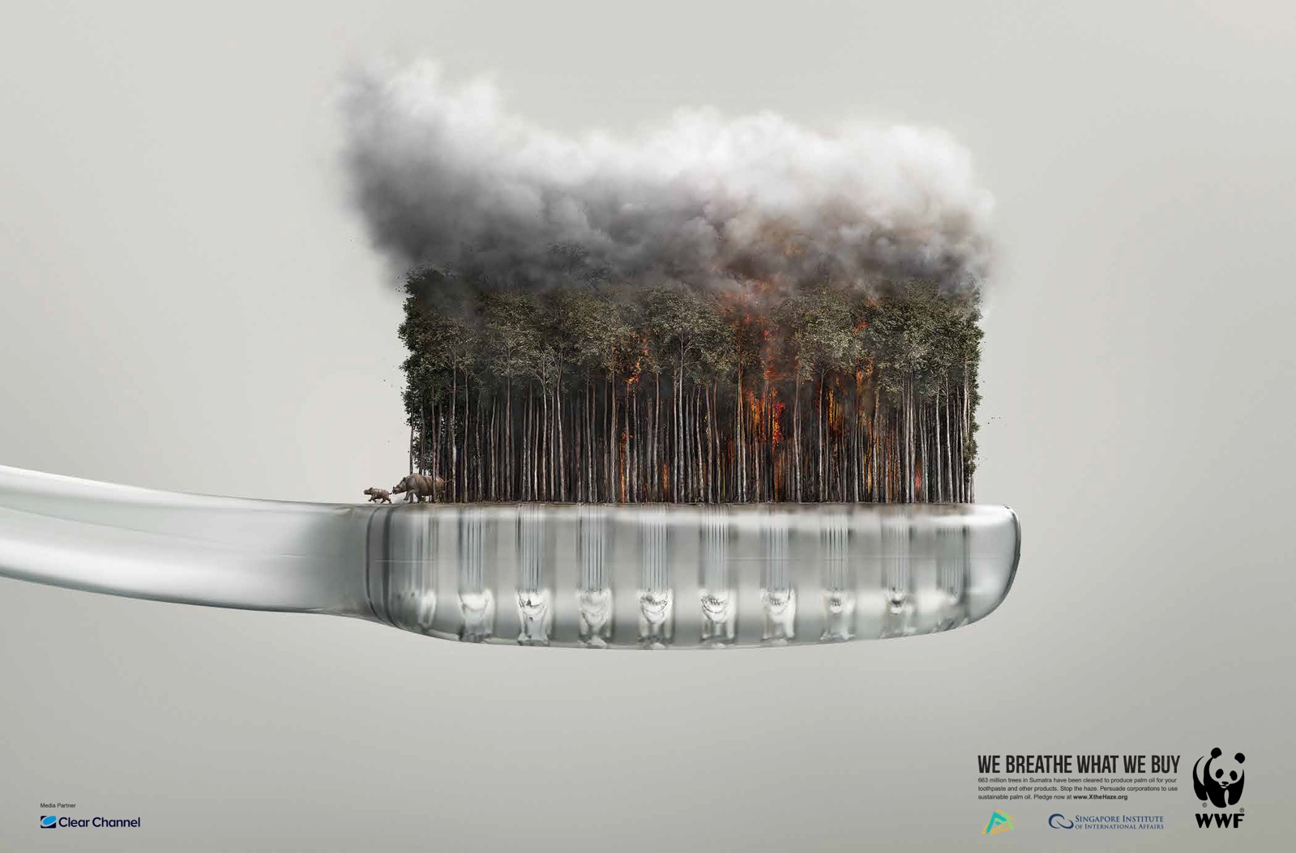

This successful poster uses techniques such as shock and an infeasible scene to draw the audience’s attention. The use of a familiar household object such as the disposable tooth brush helps make the poster relevant to people and make the audience feel more responsible for problem they are describing as generally people tend to separate themselves from the damage humans, generally, are causing. We hope to do this in our app by working out statistics based upon the user’s data which will display information such as how much ice they, personally, have melted this year or how many polar bears the have killed.

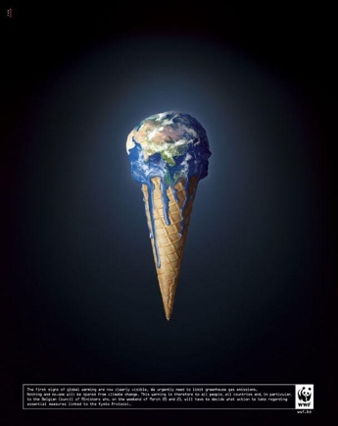**WWF (Global Warming):**

These posters show the world wasting away like a melting ice cream. This imagery gives the audience something to think about and relates to them through to the familiarity we have with an object like an ice cream cone and could make them feel more responsible for their actions. It should also hopefully make them think on how they can change their habits to make the economy/environment a better place.

### Image result for environmental pollution advertisementWWF (over/irresponsible fishing):

The minimal approach depicted in this poster is aesthetically pleasing but also creates an eerie atmosphere, assisted by the seeming endlessness of the scene depicted. The poster is clever and use a common feeling of fear towards sharks to relate to the audience but also to help put into scale the gravity of animal extinction.